How to Create a Free WordPress ePortfolio
These instructions will walk you through creating a WordPress site and some initial site configuration.

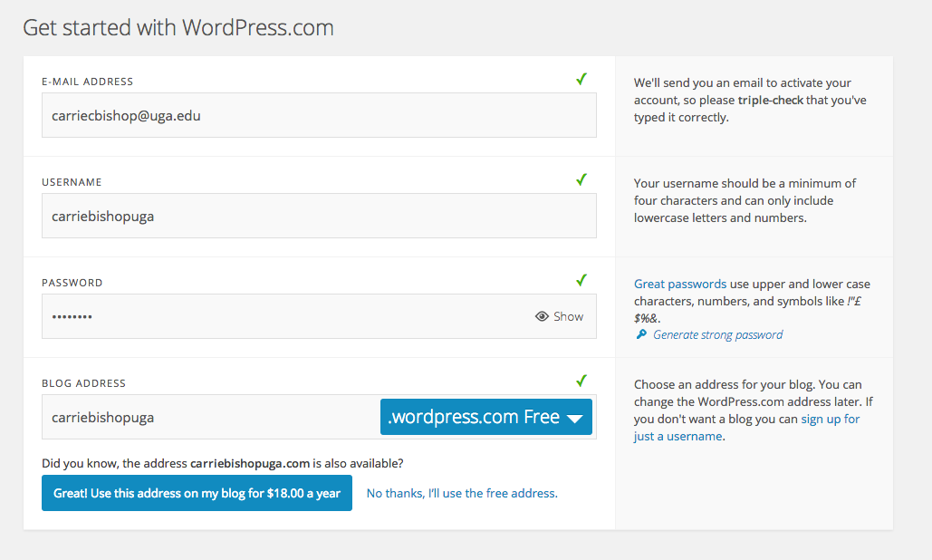
Create Your Site
- Go to http://wordpress.com
- Click Create Website
- You’ll be prompted to provide your email address, and create a username and password.

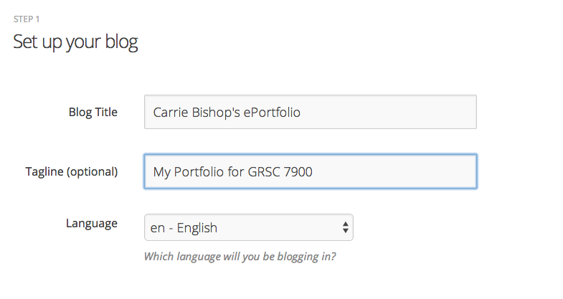
- Scroll down and click “Create blog”, in the first column, under
“WordPress.com Beginner.”

- On the next screen, enter a name for your site (Blog Title) and tagline, if you want. (This can all be edited later.) Click “Next Step.”

- Next, choose a theme for your site. We recommend “Hemingway Rewritten” as a user-friendly, simple theme. Click the theme you’d like to choose.

- The next screen allows you to customize the theme, but we’ll skip this step for now. Click Next Step.
- The next screen asks you to connect your WordPress site with a Twitter or Facebook account. You can skip this too! Click Next Step.
- Now, you’ll be taken straight to creating your first post. We’re going to skip this, because we want to create pages (not posts) on our eportfolio site. Instead, click on My Sites in the top left of your screen, and then locate the site you created.
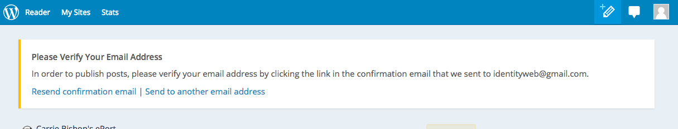
- Click the name of your site to go to your site.
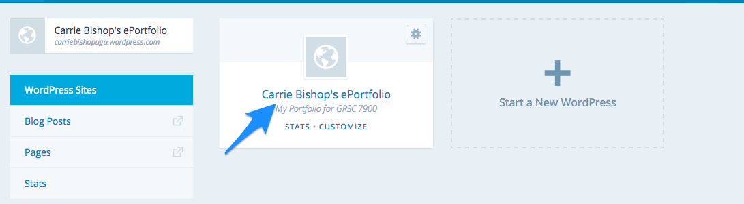

- Before you configure your site, you’ll need to verify your email address with WordPress.com. Check your email and click the link to verify.

Configure Your Site
There are two types of content in WordPress: pages and posts. Here’s the difference:
Pages are static. They are a place for information you want to share with readers. Pages don’t have time stamps so don’t show the date they are published, and you can’t assign category and tags to.

Posts are dynamic information, usually displayed in reverse-chronological order with the most recent post at the top of the page. You can assign categories and tags to posts, which make them easier to find. Posts are what you see on a blog.

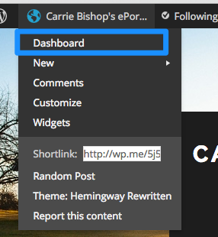
For an eportfolio, you will want to create pages. In a default free WordPress.com site, the Home page is automatically the blog, where posts are listed. We want our home page to be a page, so let’s change that setting.

Make Your Home Page a Static Page
- First, let’s create a Home page. Hover over the name of your site in the top left corner, and click on Dashboard.

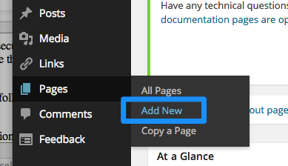

- On your left is a menu with admin options. Hover over “Pages” and click “Add New.”

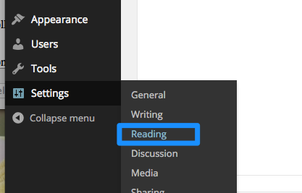
- Give your home page a title, and click Publish. You can come back and add content later. (If you only have a button for Save Draft, you still need to verify your email address.)

- Now go to your left admin menu and hover over “Settings” and choose “Reading.”

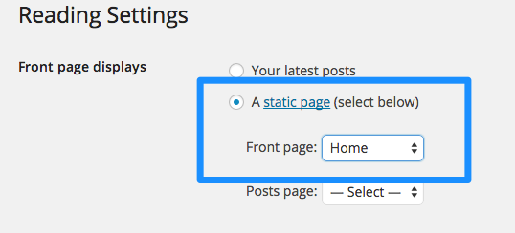
- Under “Front Page Displays,” select “A static page,” and then under Front Page, select “Home.” (this is the page you just created.)

- Scroll down and click “Save Changes.”

Create your ePortfolio Pages
- To create the other pages for your eportfolio, click Dashboard, then hover over “Pages” and click “Add New” (just like you did to create your Home page.)
- Give your page a title, and click Publish. You can come back and add content later.
- Repeat these steps for each page in your ePortfolio.

Set Up Your Menu
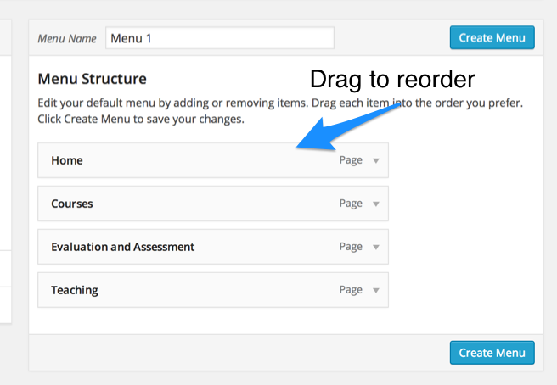
By default, when you create a new page, WordPress will automatically add it to the navigation menu. If you want to change the order of the pages or create drop down menus for certain sections, you’ll need to customize the navigation. To do this:

- Hover over the name of your site in the top left corner, and click on Dashboard.
- Hover over “Appearance” and click “Menus.”

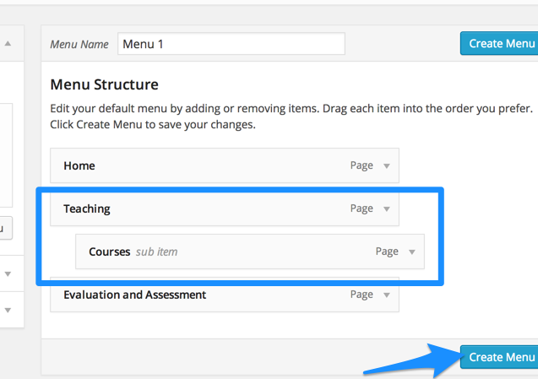
- Now you are on the menu editing screen, and you can edit the default menu that WordPress created for your site. Drag the links up and down to reorder them.

- To create drop down menus, drag a link underneath and slightly to the right of the parent link.

- When you are done editing, click “Create Menu.”

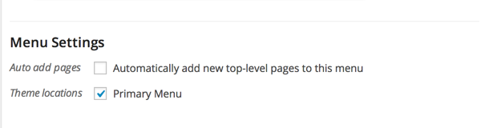
- Then, choose the location for the menu. Some WordPress will have multiple areas to place a navigation menu, but the theme in this example only has one. Check the location you want to use, and click “Save Menu.”

Set Privacy and Commenting Options
The default settings on a WordPress.com site:
- Allow your site to be publicly accessible and indexed by search engines
- Allow comments on all pages, with e-mail and name required
- Require you to approve comments if the commenter doesn’t have a previously approved comment

To change the privacy of your entire site:
- On your admin dashboard, hover over “Settings” and click “Reading.”

- Under Site Visibility, choose the setting that you want for your site.
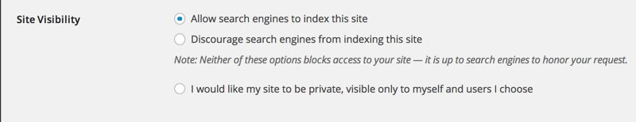

To change your commenting options:
- On your admin dashboard, hover over “Settings” and click “Discussion.”
- Select the appropriate settings for your site. If you don’t want comments on your site, uncheck “Allow people to post comments on new articles.” This will remove comments from all pages and posts on your site. (You can also remove comments on individual pages.)
